**Task on Terraform 1-2**

1) Install Terraform on your PC   
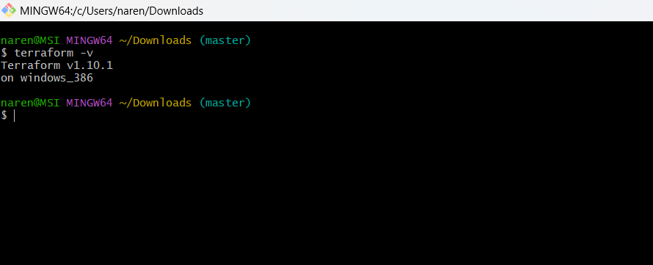

2) Execute all the templates shown in video

3) Note down below points,

Terraform Init

Terraform Plan

Terraform Apply

Terraform Provider

4) Integrate a sample Terraform template in Jenkins

5) Watch the terraform-02 video

6) Execute all the templates shown in video

lifecycle rules , create before destroy

prevent destroy

lifecycle rules /ignore changes

variables

7) Integrate terraform in jenkins using Terraform plugin.  
